Changes made to the Angular Code
- Replaced local storage with firebase storage.
Changed the local storage and entered the data to a firebase database
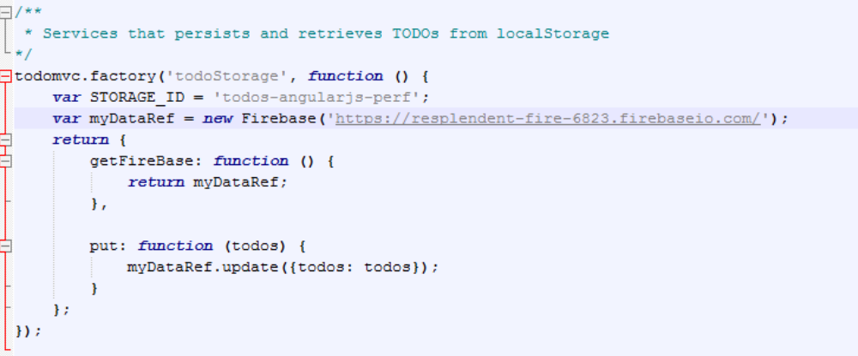

- Due date functionality added. The submit with enter button works with chrome but does not with firefox. The calendar shows up for chrome but does not come up on IE and firefox for some reason. Please use chrome for test purposes

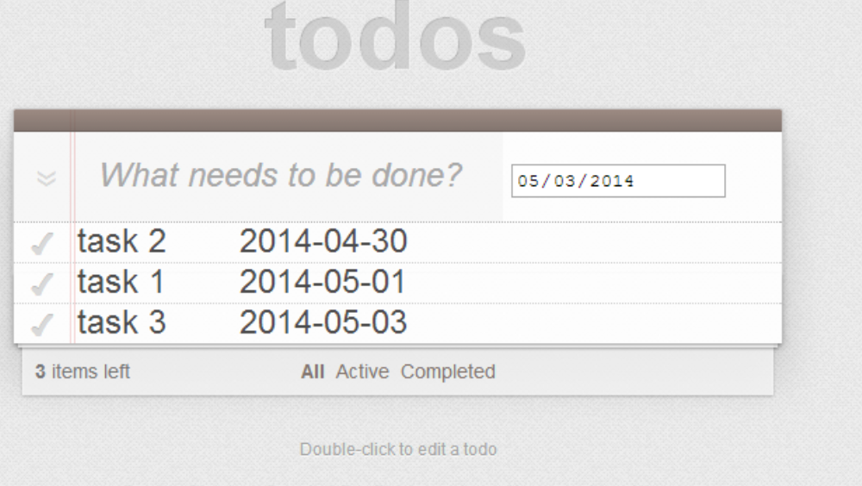
Notice the order of the tasks arranged in the order of due date and not the title.
- The sorting mechanism based on due date has been mentioned and therefore, notice the output in the order of due date. The date format is in yyyy-mm-dd.
The orderBy : ‘todoDueDate’ created the sorting order.
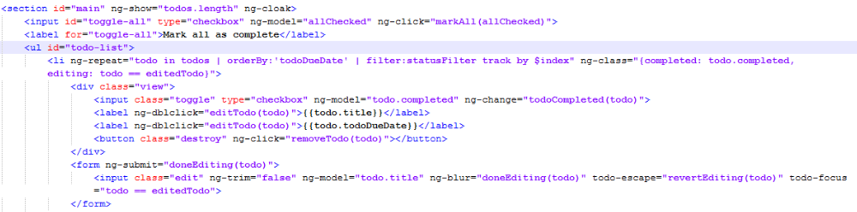

The precise location of change is here
- Some CSS changes have been made to accommodate the values of due date and task title to be shown in a single line.

